|  |
| --- |
| Virgin Strauss Water |
| Using Priority PDA application |
| User manual |



|  |
| --- |
| David Milanovic  12/3/2012 |



Virgin Strauss Water UK Ltd T: +44 (0) 845 301 7700

Henley Business Park, Pirbright Road F: +44 (0) 845 302 1962

Guildford, Surrey, GU3 2DX E: info@virginpure.com

virginpure.com

Company Reg no: 4880825 | VAT Reg no: GB 83 2101 383 | VIRGIN and the Virgin signature are registered trademarks of Virgin Enterprises Limited.

# C:\Documents and Settings\David_mi\My Documents\My Pictures\virgin pure.jpgApplication basics

****

Virgin Strauss Water UK Ltd T: +44 (0) 845 301 7700

Henley Business Park, Pirbright Road F: +44 (0) 845 302 1962

Guildford, Surrey, GU3 2DX E: info@virginpure.com

virginpure.com

Company Reg no: 4880825 | VAT Reg no: GB 83 2101 383 | VIRGIN and the Virgin signature are registered trademarks of Virgin Enterprises Limited.

**Start Priority application** to access service calls:

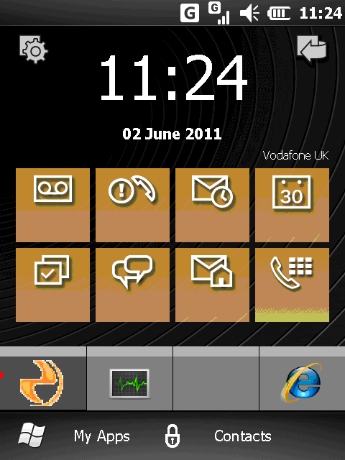\*First time users will be required to enter the provisioning code either by keyboard or by scanning their provisioning barcode

**Press Connect**

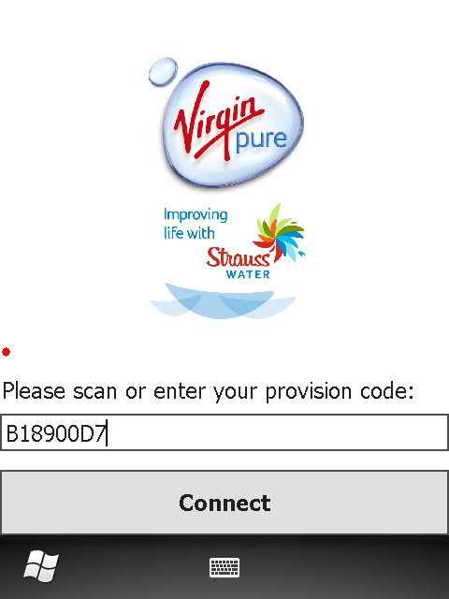

**Synchronise Calls**

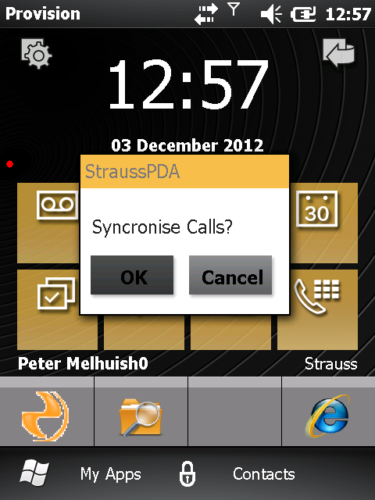

**Main Service Call List screen** will appear

Click here to view your warehouse

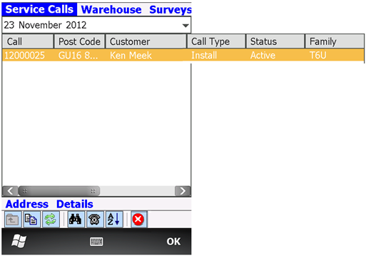

Sub-forms

(these will change depending on the status the call is in)

Click here to change the date

Click on any of the column headers to sort the calls by that value

Click on the desired call to select it

**Icons explained:**

**\***Please note that available icons change depending on the screen you are on

\*\*Icons not available on the particular scree are greyed out

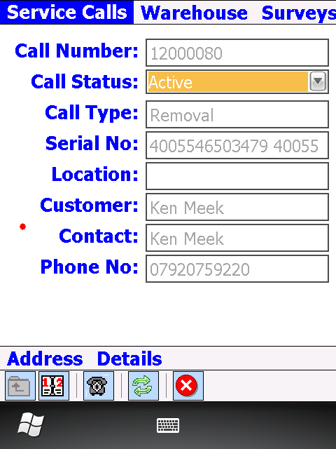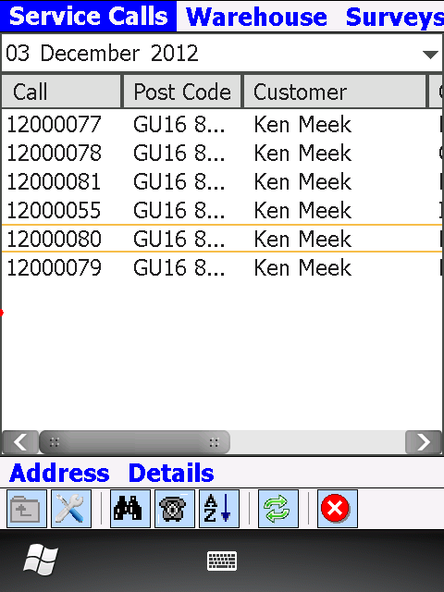

Up a level – change from sub-form to main form

View toggle – from call list to single call view

Find – starts Bar Code scanner

Close application

Dial – make a phone call

Default sort

Synchronise

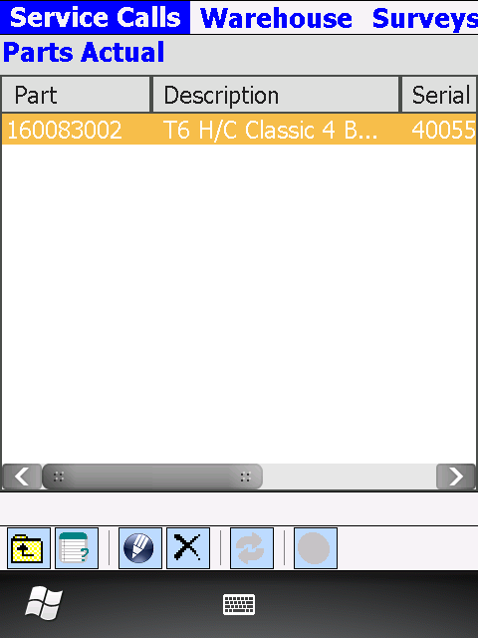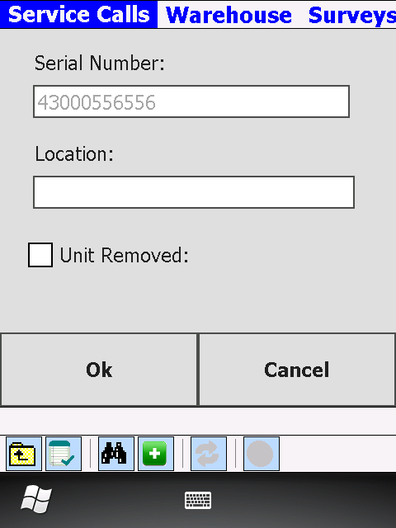

View toggle – from single call view to call list view

Delete parts

Edit parts

View toggle – from Parts Actual to Parts Planned

View toggle – from Parts Planned to Parts Actual

# C:\Documents and Settings\David_mi\My Documents\My Pictures\virgin pure.jpgDifferent screens



Virgin Strauss Water UK Ltd T: +44 (0) 845 301 7700

Henley Business Park, Pirbright Road F: +44 (0) 845 302 1962

Guildford, Surrey, GU3 2DX E: info@virginpure.com

virginpure.com

Company Reg no: 4880825 | VAT Reg no: GB 83 2101 383 | VIRGIN and the Virgin signature are registered trademarks of Virgin Enterprises Limited.

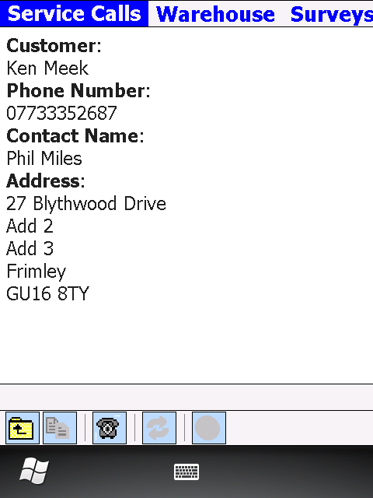

Address view

Click to return to previous view

Click to call the customer

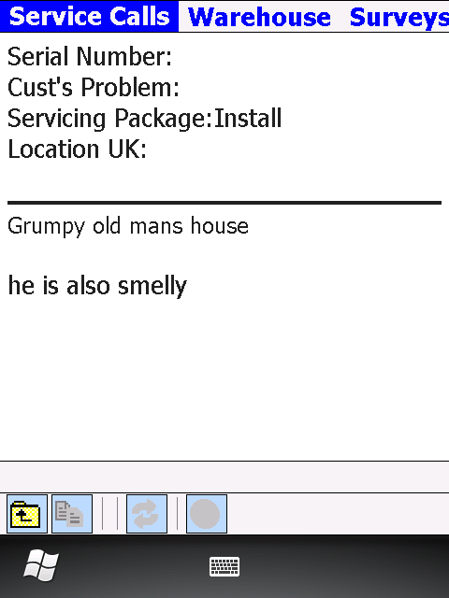

Details view

Click to return to previous view

## 

Repair view

Single call view

## 

## 

Parts Planned view

Parts Actual view

## 

## 

Signee Name field

Sign view

## 

Warehouse view

All of the columns are sortable

**Closing Application**

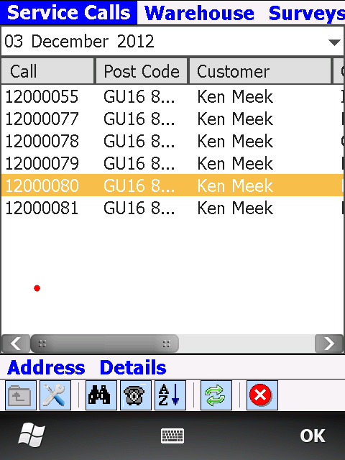

Click to confirm

Click to close

# C:\Documents and Settings\David_mi\My Documents\My Pictures\virgin pure.jpgDifferent service calls

****

Virgin Strauss Water UK Ltd T: +44 (0) 845 301 7700

Henley Business Park, Pirbright Road F: +44 (0) 845 302 1962

Guildford, Surrey, GU3 2DX E: info@virginpure.com

virginpure.com

Company Reg no: 4880825 | VAT Reg no: GB 83 2101 383 | VIRGIN and the Virgin signature are registered trademarks of Virgin Enterprises Limited.

# Install

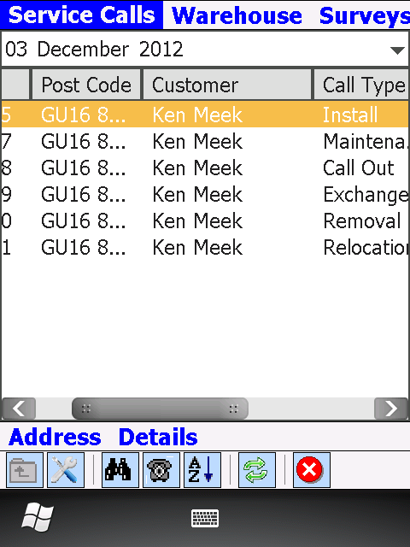

Click to view call details

Click to view address

Click once



Click to go into the single call view

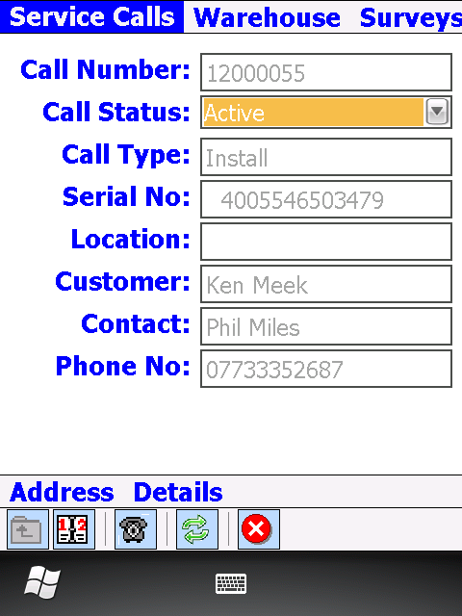

Click to choose new call status

\*Statuses have to change in order:

- En-route

- On Site

- Completed/Incomplete

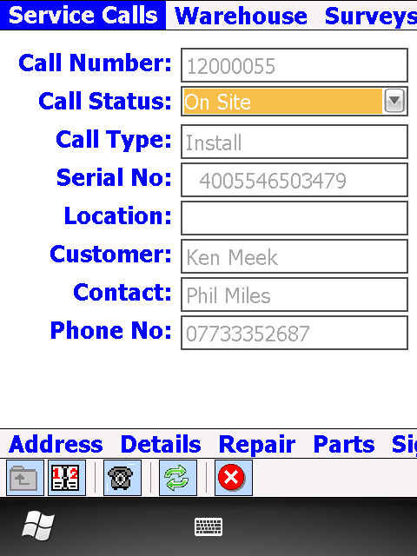

Once On Site new set of sub-forms appears

**Add Parts**

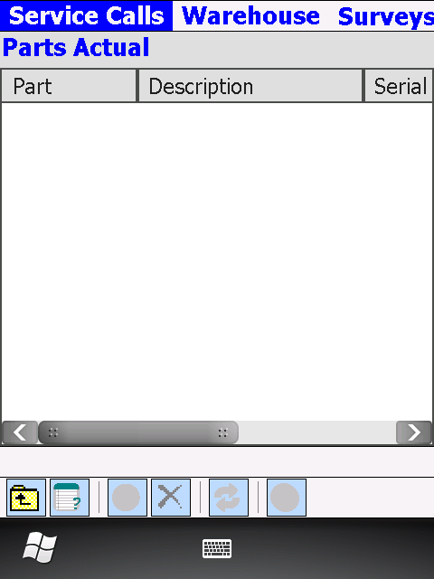

Click to go into Parts Planned

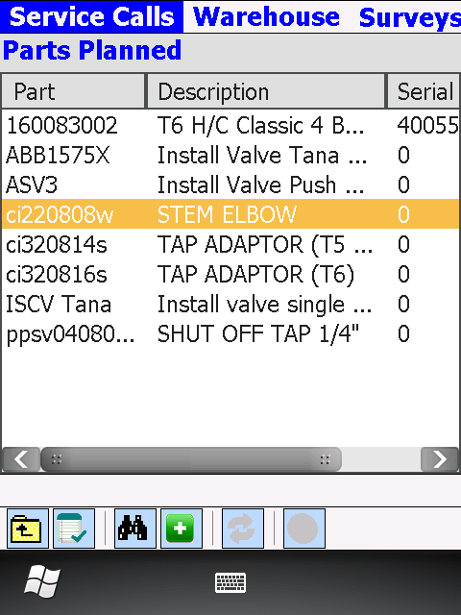

Click to add the part

Serialised parts have to be scanned via the binoculars button **first**!

Alternatively click here to scan the part barcode

Click to view address

Click to add selected part

Click to select a part

\*All serialised parts require location. The dialog screen will pop up requiering you to ender the location.

\*\*If unit is dead on arrival Unit Removed tick box will have to be selected. In this case location is not necessary.

fa

Once all the part have been added go back to **Parts Actual** screen

**Adding parts from the warehouse**

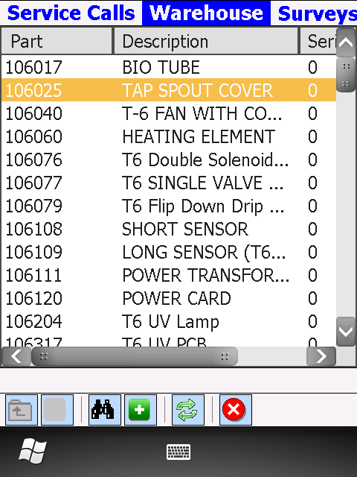

Click to select a part

Click to add the part

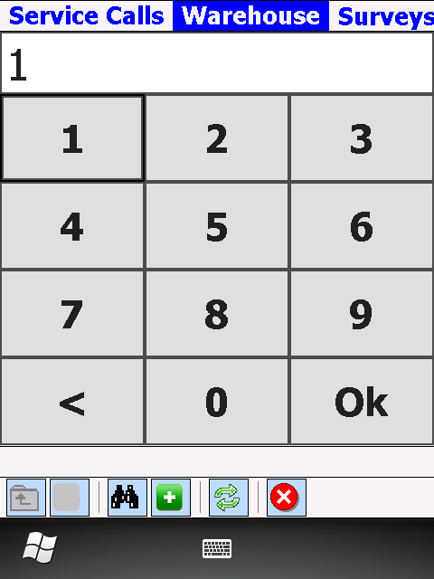

Click OK

Enter quantity

**Return to the Service Calls screen** by pressing on Service Calls tab

Once finished adding parts use ‘Up a level’ button to return to the main Service Call view

**Fill in Repair** sub-form

\*You must put notes into the notes field in order to later Complete the call.

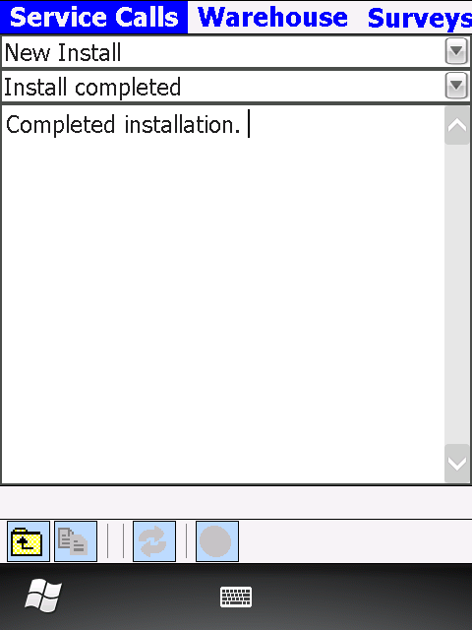

Once finished use ‘Up a level’ button to return to the main Service Call view

**Go to Sign** sub-form to obtain the customer signature

\*Signee name field is mandatory, take customer name and enter it into this field

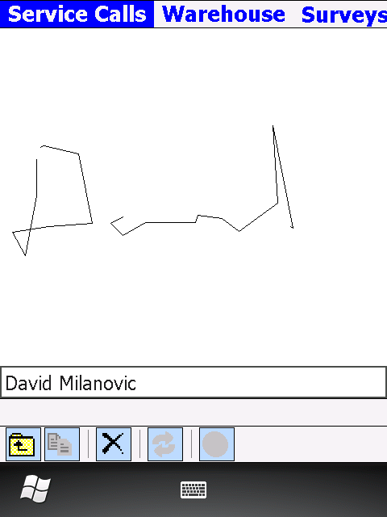

Once completed, use ‘Up a level’ button to return to Service Calls main view

**Change Call Status to Completed/Incomplete.**

\*A popup dialogue box will ask for confirmation before it sets the call status to Completed/Incomplete

\*\*If some of the mandatory fields are not filled in, the application will show an error screen

# Service Call/Maintenance

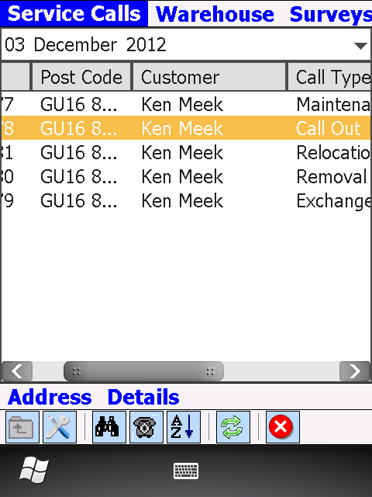

… click on the binoculars and scan the serial number of the machine which you are about the service

Select a call or

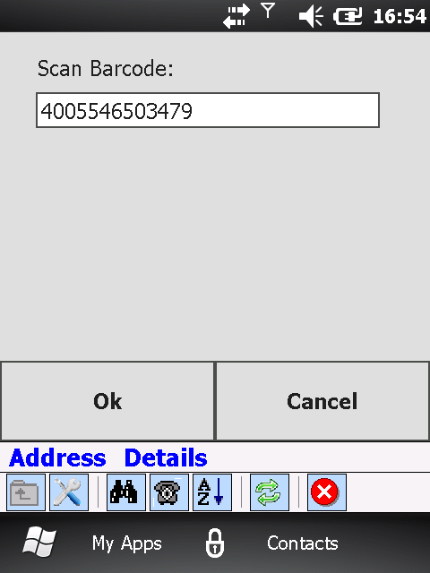

This will automatically open the call for that serial number

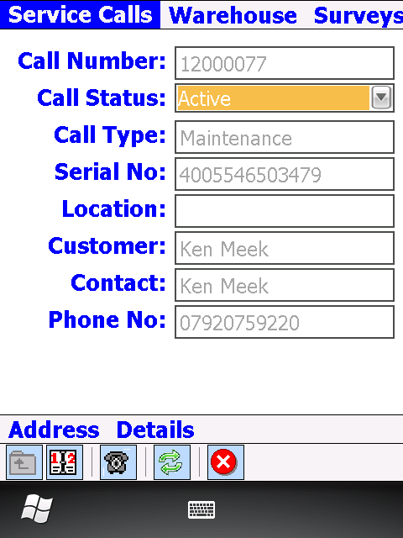

Select the appropriate Call Status (En-Route, On Site)

Ensure you contacted the customer by pressing the Dial button

**Add Parts**



Click to go into Parts Planned



Click to add the part

Alternatively click here to scan the part barcode

Click to view address

Click to add selected part

Click to select a part

**Adding parts from the warehouse**



Click to select a part

Click to add the part



Click OK

Enter quantity

**Return to the Service Calls screen** by pressing on Service Calls tab

Once finished adding parts use ‘Up a level’ button to return to the main Service Call view

**Fill in Repair** sub-form

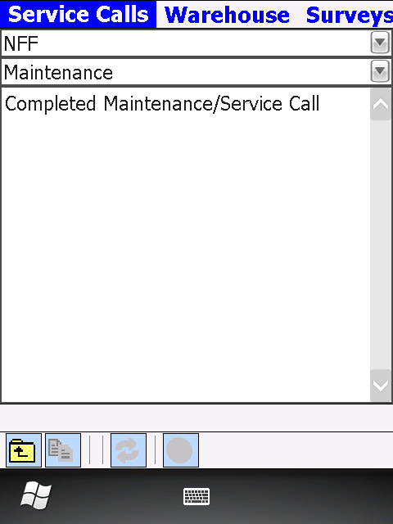

Once finished use ‘Up a level’ button to return to the main Service Call view

**Go to Sign** sub-form to obtain the customer signature

\*Signee name field is mandatory, take customer name and enter it into this field



Once completed, use ‘Up a level’ button to return to Service Calls main view

**Change Call Status to Completed/Incomplete.**

\*A popup dialogue box will ask for confirmation before it sets the call status to Completed/Incomplete

\*\*If some of the mandatory fields are not filled in, the application will show an error screen

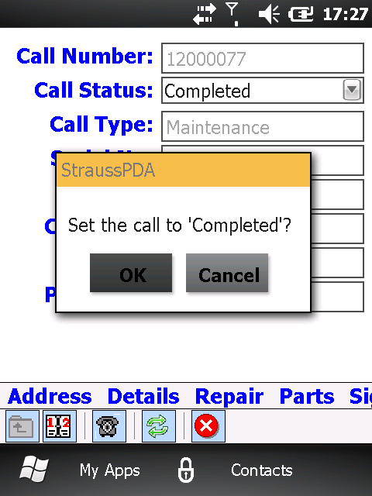

Press to return to the Call List screen

# Exchange



… click on the binoculars and scan the serial number of the machine which you are about the service

Select a call or



This will automatically open the call for that serial number

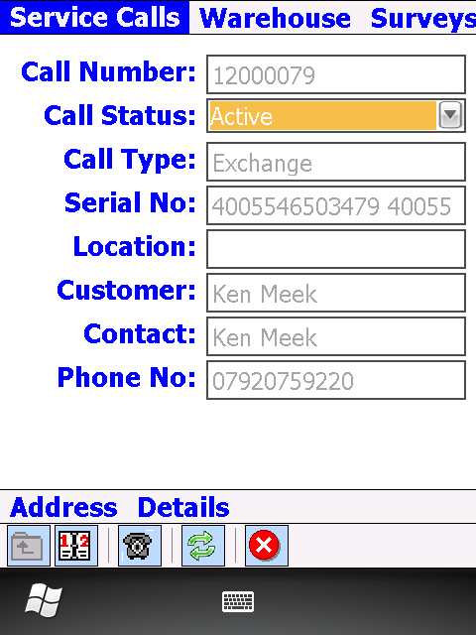

Select the appropriate Call Status (En-Route, On Site)

Ensure you contacted the customer by pressing the Dial button

**Add Parts**



Click to go into Parts Planned

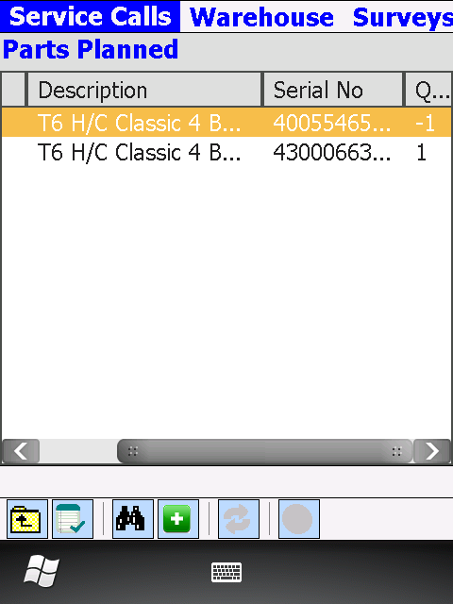

Click to select a part

Click to add the part

Alternatively click here to scan the part barcode

Click to view address

Click to add selected part

\*Please note there are 2 machines on Exchange calls, one which is being removed (quantity -1) and one being installed (quantity 1). It is imperative to add them both in order to complete the exchange successfully

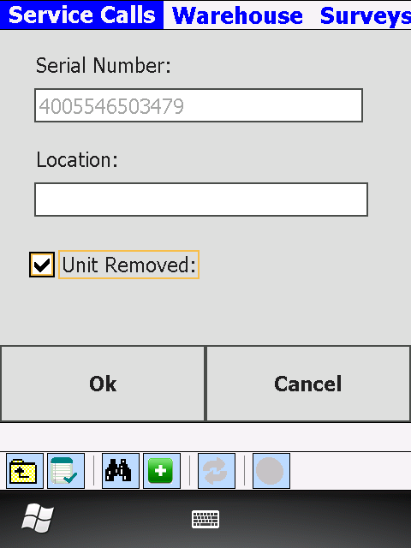

Click OK to add this part

Tick this for the unit being removed

Return to Parts Actual screen and verify both machines are there:

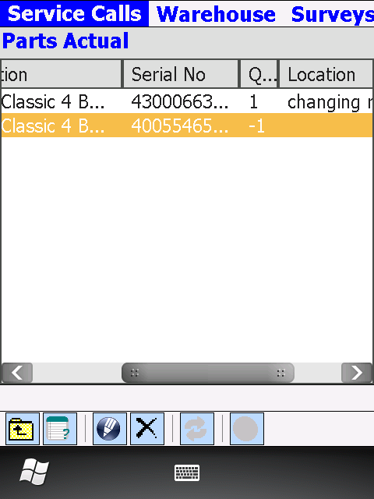

**Adding parts from the warehouse**



Click to select a part

Click to add the part



Click OK

Enter quantity

**Return to the Service Calls screen** by pressing on Service Calls tab

Once finished adding parts use ‘Up a level’ button to return to the main Service Call view

**Fill in Repair** sub-form

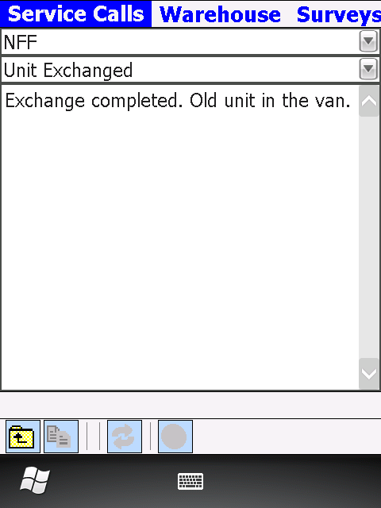

Once finished use ‘Up a level’ button to return to the main Service Call view

**Go to Sign** sub-form to obtain the customer signature

\*Signee name field is mandatory, take customer name and enter it into this field



Once completed, use ‘Up a level’ button to return to Service Calls main view

**Change Call Status to Completed/Incomplete.**

\*A popup dialogue box will ask for confirmation before it sets the call status to Completed/Incomplete

\*\*If some of the mandatory fields are not filled in, the application will show an error screen

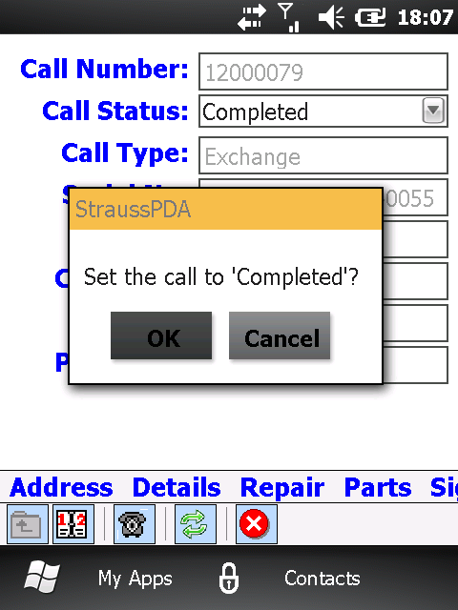

Press to return to the Call List screen

# Removal

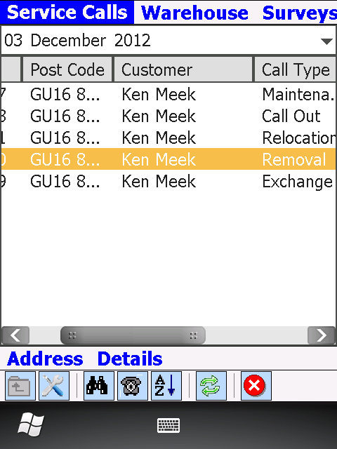

Select a call or …

… click on the binoculars and scan the serial number of the machine which you are about the service



This will automatically open the call for that serial number

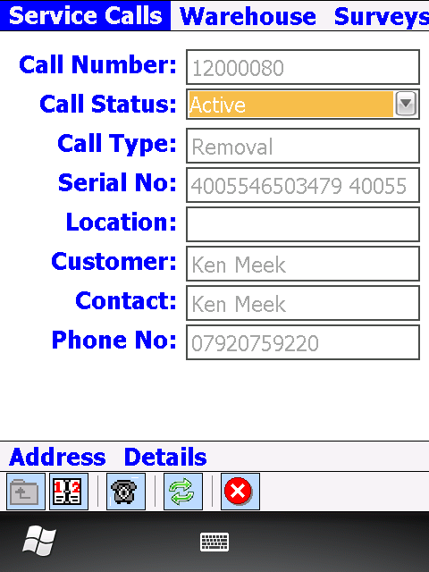

Select the appropriate Call Status (En-Route, On Site)

Ensure you contacted the customer by pressing the Dial button

**Add Parts**



Click to go into Parts Planned

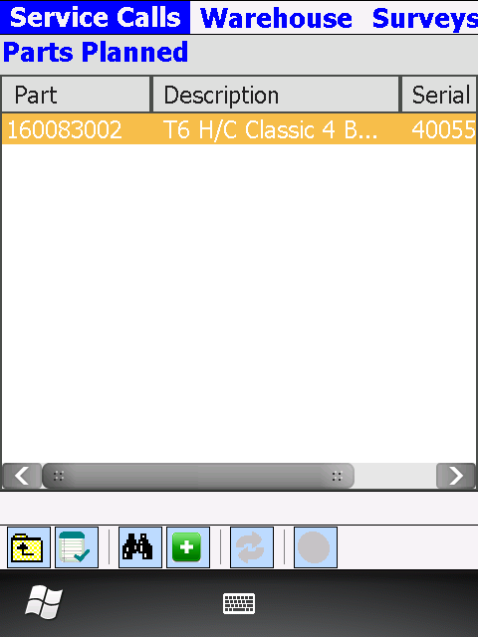

Click to select a part

Click to add the part

Alternatively click here to scan the part barcode

Click to view address

Click to add selected part

\*Please note there is only one planned serialised part number on the call and it will have a quantity on -1



Click OK to add this part

Tick this for the unit being removed

Return to Parts Actual screen and verify machine is there:

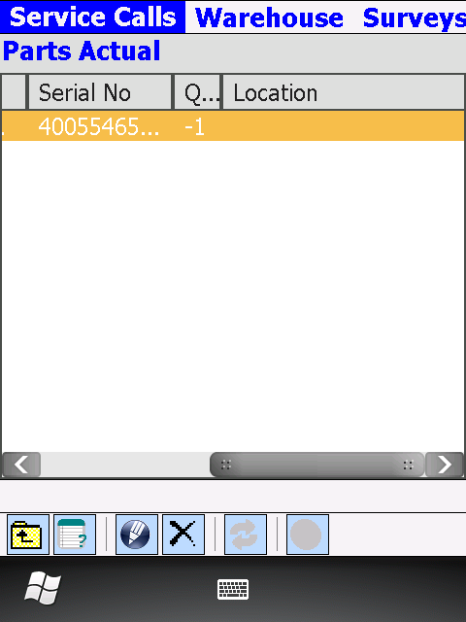

Once finished adding parts use ‘Up a level’ button to return to the main Service Call view

**Fill in Repair** sub-form

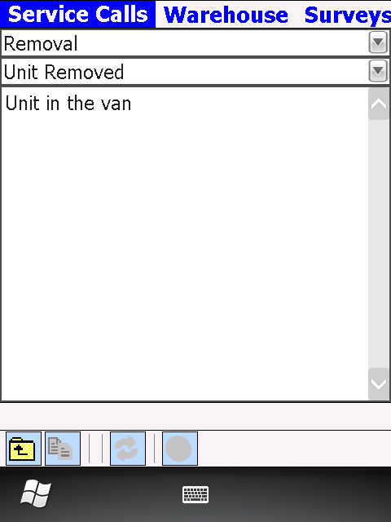

Once finished use ‘Up a level’ button to return to the main Service Call view

**Go to Sign** sub-form to obtain the customer signature

\*Signee name field is mandatory, take customer name and enter it into this field



Once completed, use ‘Up a level’ button to return to Service Calls main view

**Change Call Status to Completed/Incomplete.**

\*A popup dialogue box will ask for confirmation before it sets the call status to Completed/Incomplete

\*\*If some of the mandatory fields are not filled in, the application will show an error screen



Press to return to the Call List screen